Questions:
- Does this zero Ohm resistor need to stay or can I remove it?
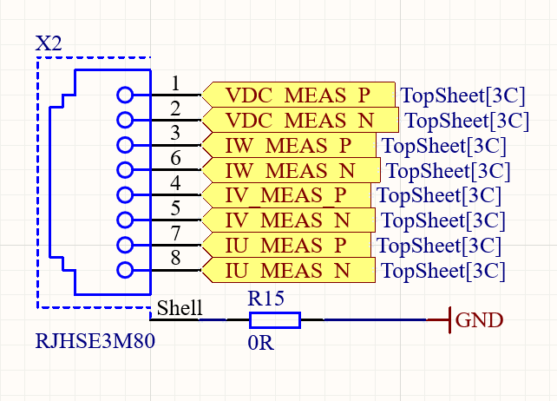
- Does it matter what type of model I downloaded from ultrarian library?
  - Sequential or functional

